Part 1

How to use MySQL Workbench  
and other development tools

Before you start the exercises…

Before you start these exercises, you need to install the MySQL server and MySQL Workbench. The procedures for doing that are provided in appendix A (Windows) and B (macOS).

In addition, you’ll need to get the mgs_ex_starts directory from your instructor. This directory contains some script files that you need to do the exercises.

Exercises

In these exercises, you’ll use MySQL Workbench to create the My Guitar Shop database, to review the tables in this database, and to enter SQL statements and run them against this database.

Make sure the MySQL server is running

1. Start MySQL Workbench and open a connection for the root user.
2. Check whether the MySQL server is running. If it isn’t, start it.

Use MySQL Workbench to create the My Guitar Shop database.

1. Open the script file named my_guitar_shop.sql that’s in the mgs_ex_starts directory by clicking the Open SQL Script File button in the SQL Editor toolbar. Then, use the resulting dialog box to locate and open the file.
2. Execute the entire script by clicking the Execute SQL Script button in the SQL editor toolbar or by pressing Ctrl+Shift+Enter. When you do, the Output window displays messages that indicate whether the script executed successfully.

Use MySQL Workbench to review the My Guitar Shop database

1. In the Schemas category of the Navigator window, expand the node for the database named my_guitar_shop so you can see all of the database objects it contains. If it isn’t displayed in the Schemas tab of the Navigator window, you may need to click on the Refresh button to display it.

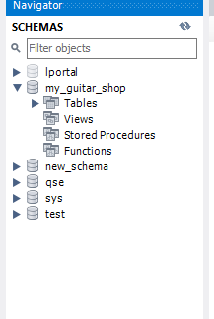

1. View the data for the Categories and Products tables.
2. Navigate through the database objects and view the column definitions for at least the Categories and Products tables.

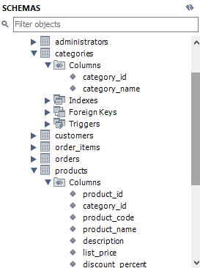

Use MySQL Workbench to enter and run SQL statements

1. Double-click on the my_guitar_shop database to set it as the default database. When you do that, MySQL Workbench should display the database in bold.
2. Open a SQL editor tab. Then, enter and run this SQL statement:

SELECT product_name FROM products

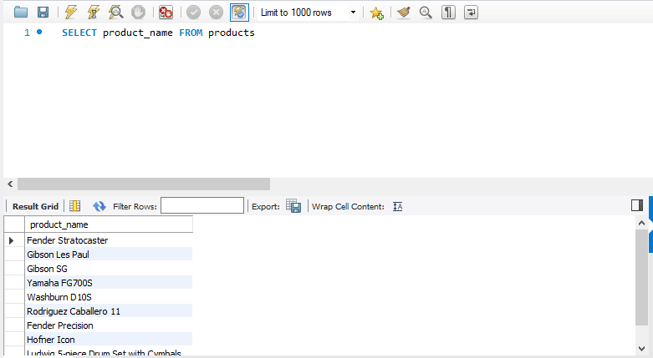

1. Delete the *e* at the end of product_name and run the statement again. Note the error number and the description of the error.



1. Open another SQL editor tab. Then, enter and run this statement:

SELECT COUNT(*) AS number_of_products

FROM products

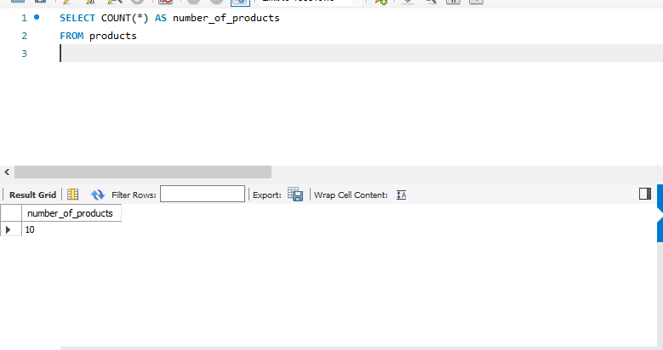

Use MySQL Workbench to open and run scripts

1. Open the script named product_details.sql that’s in the mgs_ex_starts directory. Note that this script contains just one SQL statement. Then, run the statement.

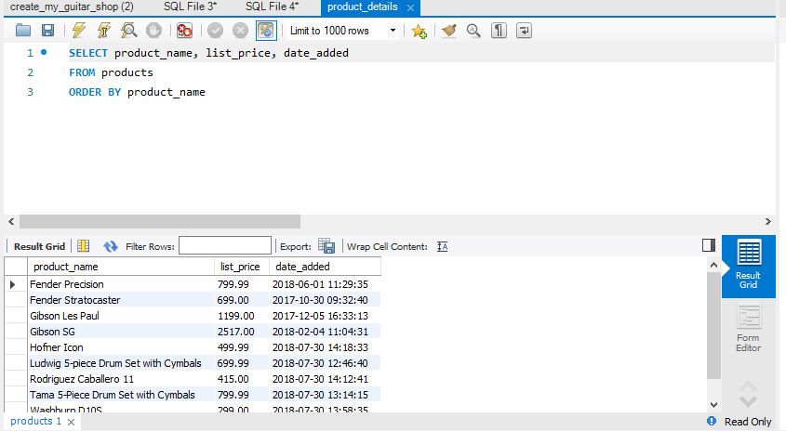

1. Open the script named product_summary.sql that’s in the mgs_ex_starts directory. Note that this opens another SQL editor tab.

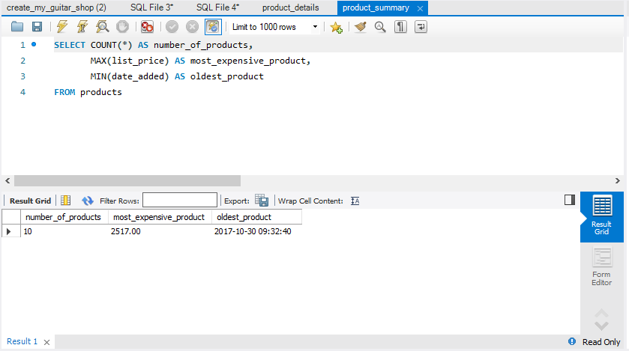

1. Open the script named product_statements.sql that’s in the mgs_ex_starts directory. Notice that this script contains two SQL statements that end with semicolons.
2. Press the Ctrl+Shift+Enter keys or click the Execute SQL Script button to run both of the statements in this script. Note that this displays the results in two Result tabs. Make sure to view the results of both SELECT statements.  
   **Result 1:**

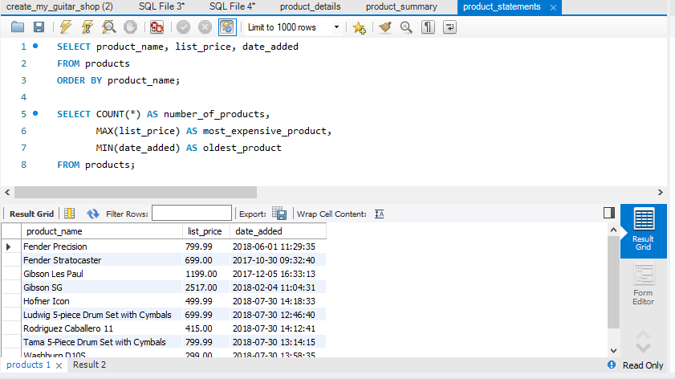

**Result 2:**

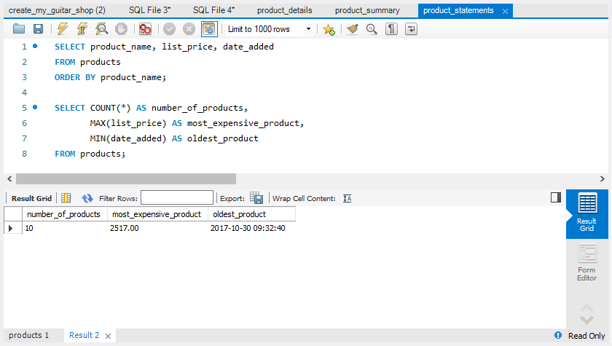

1. Move the insertion point into the first statement and press Ctrl+Enter to run just that statement.
2. Move the insertion point into the second statement and press Ctrl+Enter to run just that statement.
3. Exit from MySQL Workbench.

Part 2

How to retrieve data   
from a single table

Exercises

Enter and run your own SELECT statements

In these exercises, you’ll enter and run your own SELECT statements.

1. Write a SELECT statement that returns four columns from the Products table: product_code, product_name, list_price, and discount_percent. Then, run this statement to make sure it works correctly.

Add an ORDER BY clause to this statement that sorts the result set by list price in descending sequence. Then, run this statement again to make sure it works correctly. This is a good way to build and test a statement, one clause at a time.

**SELECT product_code, product_name, list_price, discount_percent FROM products ORDER BY list_price desc**

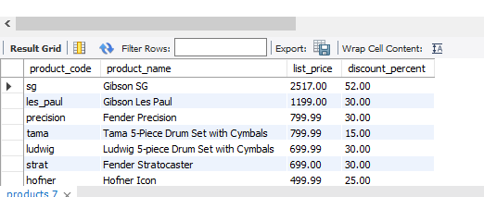

1. Write a SELECT statement that returns one column from the Customers table named full_name that joins the last_name and first_name columns.

Format this column with the last name, a comma, a space, and the first name like this:

Doe, John

Sort the result set by the last_name column in ascending sequence.

Return only the customers whose last name begins with letters from M to Z.

NOTE: When comparing strings of characters, ‘M’ comes before any string of characters that begins with ‘M’. For example, ‘M’ comes before ‘Murach’.

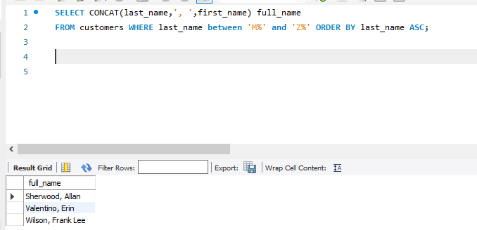

1. Write a SELECT statement that returns these columns from the Products table:

product_name The product_name column

list_price The list_price column

date_added The date_added column

Return only the rows with a list price that’s greater than 500 and less than 2000.

Sort the result set by the date_added column in descending sequence.

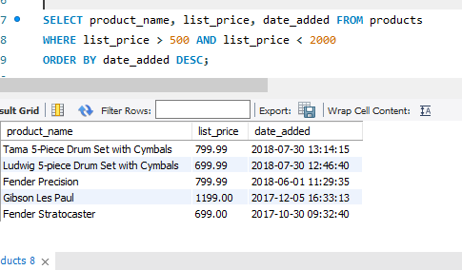

1. Write a SELECT statement that returns these column names and data from the Products table:

product_name The product_name column

list_price The list_price column

discount_percent The discount_percent column

discount_amount A column that’s calculated from the previous two columns

discount_price A column that’s calculated from the previous three columns

Round the discount_amount and discount_price columns to 2 decimal places.

Sort the result set by the discount_price column in descending sequence.

Use the LIMIT clause so the result set contains only the first 5 rows.

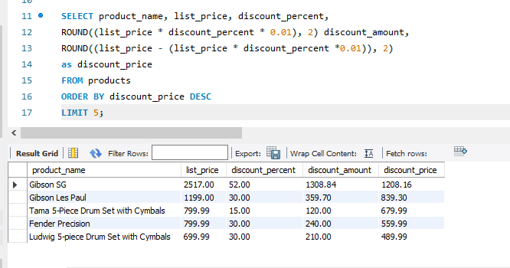

1. Write a SELECT statement that returns these column names and data from the Order_Items table:

item_id The item_id column

item_price The item_price column

discount_amount The discount_amount column

quantity The quantity column

price_total A column that’s calculated by multiplying the item price by the quantity

discount_total A column that’s calculated by multiplying the discount amount by the quantity

item_total A column that’s calculated by subtracting the discount amount from the item price and then multiplying by the quantity

Only return rows where the item_total is greater than 500.

Sort the result set by the item_total column in descending sequence.

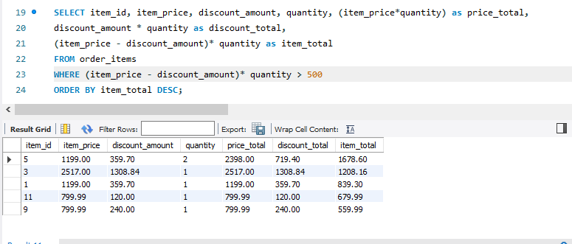

Work with nulls and test expressions

1. Write a SELECT statement that returns these columns from the Orders table:

order_id The order_id column

order_date The order_date column

ship_date The ship_date column

Return only the rows where the ship_date column contains a null value.

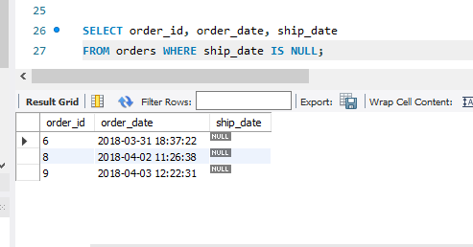

1. Write a SELECT statement without a FROM clause that uses the NOW function to create a row with these columns:

today_unformatted The NOW function unformatted

today_formatted The NOW function in this format:   
DD-Mon-YYYY

This displays a number for the day, an abbreviation for the month, and a four-digit year.

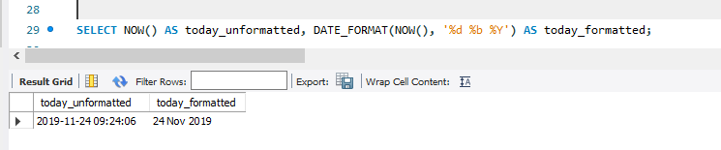

1. Write a SELECT statement without a FROM clause that creates a row with these columns:

price 100 (dollars)

tax_rate .07 (7 percent)

tax_amount The price multiplied by the tax

total The price plus the tax

To calculate the fourth column, add the expressions you used for the first and third columns.

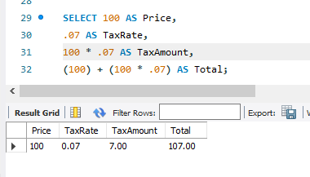

Part 3

How to retrieve data   
from two or more tables

Exercises

1. Write a SELECT statement that joins the Categories table to the Products table and returns these columns: category_name, product_name, list_price.

Sort the result set by the category_name column and then by the product_name column in ascending sequence.  
**SELECT category_name, product_name, list_price FROM categories JOIN products ON categories.category_id = products.category_id**

**ORDER BY category_name, product_name asc**

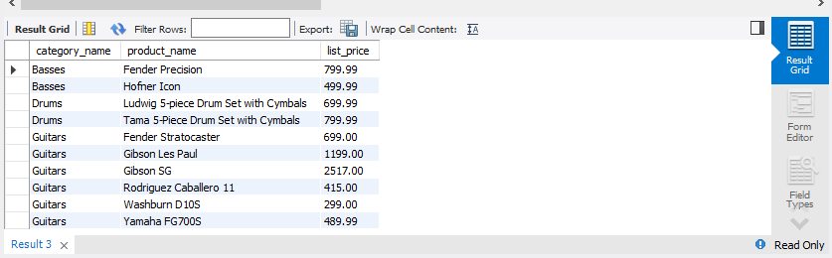

1. Write a SELECT statement that joins the Customers table to the Addresses table and returns these columns: first_name, last_name, line1, city, state, zip_code.

Return one row for each address for the customer with an email address of [allan.sherwood@yahoo.com](mailto:allan.sherwood@yahoo.com).

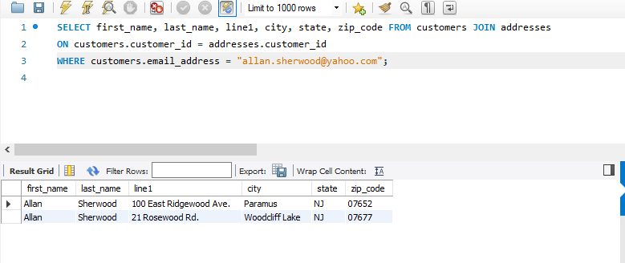

1. Write a SELECT statement that joins the Customers table to the Addresses table and returns these columns: first_name, last_name, line1, city, state, zip_code.

Return one row for each customer, but only return addresses that are the shipping address for a customer.

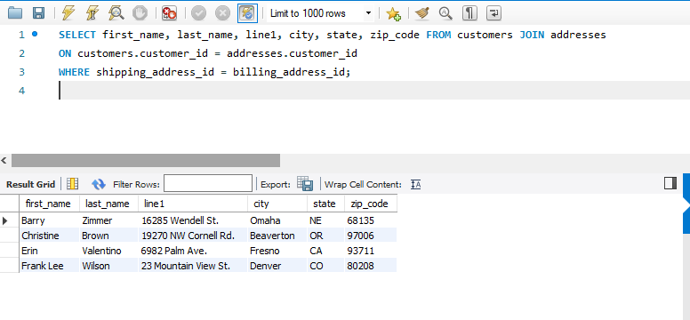

1. Write a SELECT statement that joins the Customers, Orders, Order_Items, and Products tables. This statement should return these columns: last_name, first_name, order_date, product_name, item_price, discount_amount, and quantity.

Use aliases for the tables.

Sort the final result set by the last_name, order_date, and product_name columns.  
**SELECT last_name, first_name, order_date, product_name, item_price, discount_amount, quantity**

**FROM customers as cust JOIN orders as o ON cust.customer_id = o.customer_id**

**JOIN order_items as oi ON oi.order_id = o.order_id**

**JOIN products as p ON p.product_id = oi.product_id**

**ORDER BY last_name, order_date, product_name;**

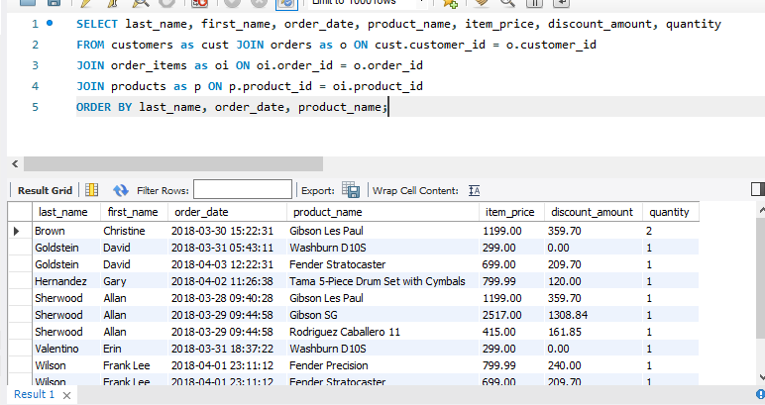

1. Write a SELECT statement that returns the product_name and list_price columns from the Products table.

Return one row for each product that has the same list price as another product.   
*Hint: Use a self-join to check that the product_id columns aren’t equal but the list_price columns are equal.*

Sort the result set by the product_name column.

**SELECT p1.product_name, p1.list_price**

**FROM products AS p1**

**JOIN products AS p2 ON p1.product_id <> p2.product_id**

**AND p1.list_price = p2.list_price**

**ORDER BY product_name**

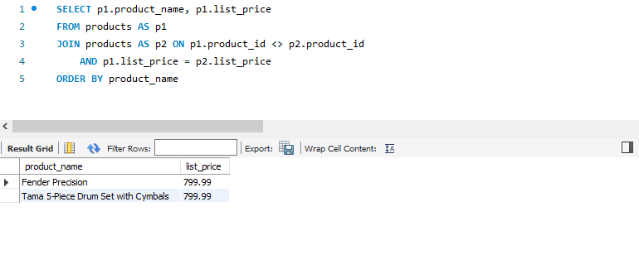

1. Write a SELECT statement that returns these two columns:

category_name The category_name column from the Categories table

product_id The product_id column from the Products table

Return one row for each category that has never been used. *Hint: Use an outer join and only return rows where the product_id column contains a null value.*

**SELECT category_name**

**, product_id**

**FROM categories LEFT**

**JOIN products ON categories.category_id = products.product_id**

**WHERE product_id IS NULL**

1. Use the UNION operator to generate a result set consisting of three columns from the Orders table:

ship_status A calculated column that contains a value of SHIPPED or NOT SHIPPED

order_id The order_id column

order_date The order_date column

If the order has a value in the ship_date column, the ship_status column should contain a value of SHIPPED. Otherwise, it should contain a value of NOT SHIPPED.

Sort the final result set by the order_date column.  
**SELECT 'SHIPPED' AS shipment_status, order_id, order_date FROM orders**

**WHERE ship_date IS NOT NULL**

**UNION**

**SELECT 'NOT SHIPPED', order_id, order_date FROM orders**

**WHERE ship_date IS NULL ORDER BY order_date**

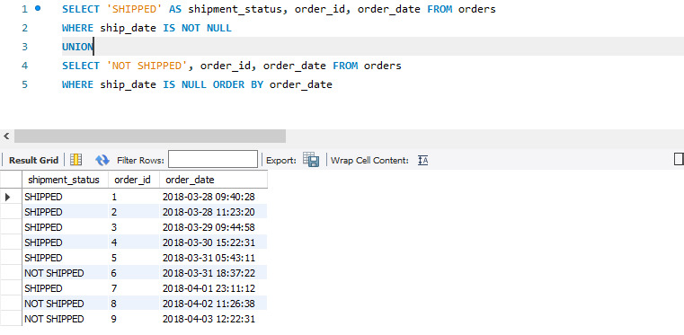

Part 4

How to insert, update, and delete data

Exercises

To test whether a table has been modified correctly as you do these exercises, you can write and run an appropriate SELECT statement.

1. Write an INSERT statement that adds this row to the Categories table:

category_name: Brass

Code the INSERT statement so MySQL automatically generates the category_id column.

**INSERT INTO categories (category_name) VALUES (‘Brass’);**

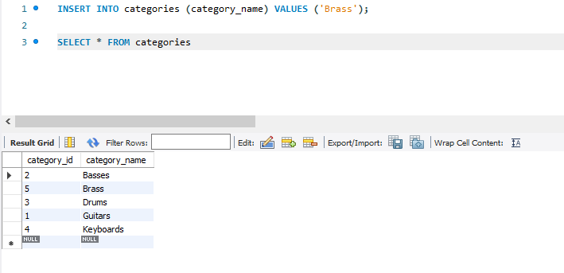

1. Write an UPDATE statement that modifies the row you just added to the Categories table. This statement should change the product_name column to “Woodwinds”, and it should use the category_id column to identify the row.  
   **UPDATE categories SET category_name = 'Woodwinds' WHERE category_id = 5;**
2. Write a DELETE statement that deletes the row you added to the Categories table in exercise 1. This statement should use the category_id column to identify the row.  
   **DELETE FROM categories WHERE category_id = 2;**
3. Write an INSERT statement that adds this row to the Products table:

product_id: The next automatically generated ID   
category_id: 4  
product_code: dgx_640  
product_name: Yamaha DGX 640 88-Key Digital Piano  
description: Long description to come.  
list_price: 799.99  
discount_percent: 0  
date_added: Today’s date/time.

Use a column list for this statement.  
**INSERT INTO products (category_id, product_code, product_name, description, list_price,**

**discount_percent, date_added) VALUES (4, 'dgx_640','Yamaha DGX 640 88-Key Digital Piano',**

**'Long description to come.',799.99,0,CURRENT_TIMESTAMP);**

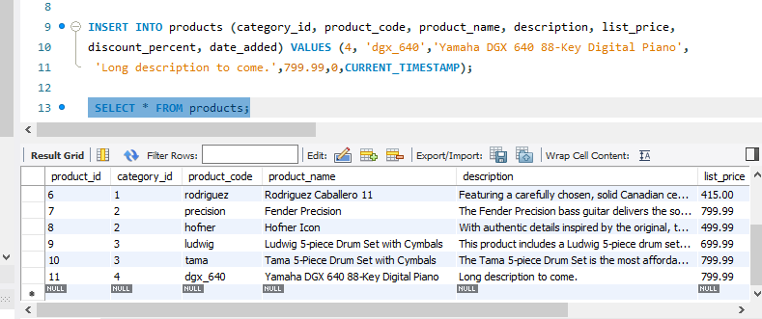

1. Write an UPDATE statement that modifies the product you added in exercise 4. This statement should change the discount_percent column from 0% to 35%.
2. 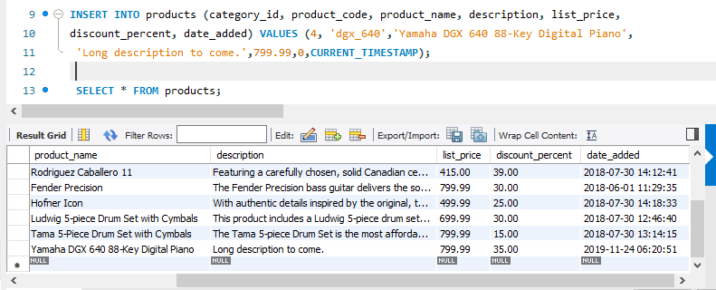
3. Write a DELETE statement that deletes the Keyboards category. When you execute this statement, it will produce an error since the category has related rows in the Products table. To fix that, precede the DELETE statement with another DELETE statement that deletes all products in this category. (Remember that to code two or more statements in a script, you must end each statement with a semicolon.)

**SELECT statement reveals the id for keyboards categories and then that id is used to execute delete statements.**

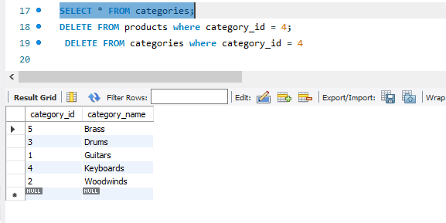

1. Write an INSERT statement that adds this row to the Customers table:

email_address: rick@raven.com  
password: (empty string)  
first_name: Rick  
last_name: Raven

Use a column list for this statement.  
**INSERT INTO customers (email_address, password, first_name, last_name) VALUES ('rick@raven.com', '', 'Rick', 'Raven');**

1. Write an UPDATE statement that modifies the Customers table. Change the password column to “secret” for the customer with an email address of rick@raven.com.  
   **UPDATE customers SET password = 'secret' WHERE email_address = 'rick@raven.com';**
2. Write an UPDATE statement that modifies the Customers table. Change the password column to “reset” for every customer in the table. If you get an error due to safe-update mode, you can add a LIMIT clause to update the first 100 rows of the table. (This should update all rows in the table.)  
   **UPDATE customers SET password = 'reset';**
3. Open the script named create_my_guitar_shop.sql that’s in the mgs_ex_starts directory. Then, run this script. That should restore the data that’s in the database.

Part 5

How to code summary queries

Exercises

1. Write a SELECT statement that returns these columns:

The count of the number of orders in the Orders table

The sum of the tax_amount columns in the Orders table

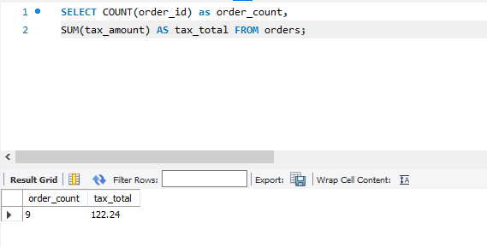

1. Write a SELECT statement that returns one row for each category that has products with these columns:

The category_name column from the Categories table

The count of the products in the Products table

The list price of the most expensive product in the Products table

Sort the result set so the category with the most products appears first.

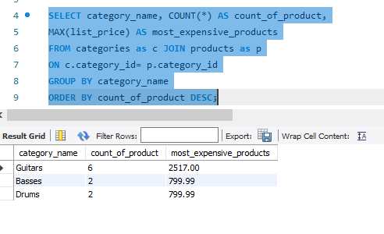

1. Write a SELECT statement that returns one row for each customer that has orders with these columns:

The email_address column from the Customers table

The sum of the item price in the Order_Items table multiplied by the quantity in the Order_Items table

The sum of the discount amount column in the Order_Items table multiplied by the quantity in the Order_Items table

Sort the result set in descending sequence by the item price total for each customer.  
***SELECT SUM(item_price * quantity) AS total_prices, email_address,***

***SUM(discount_amount * quantity) AS total_discounted***

***FROM Customers c***

***JOIN orders as o ON c.customer_id = o.customer_id***

***JOIN order_items as oi ON o.order_id = oi.order_id***

***GROUP BY email_address***

***ORDER BY total_prices DESC;***

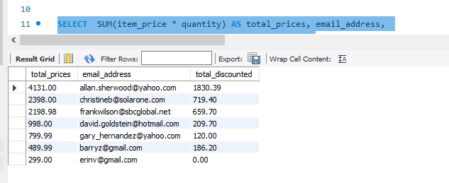

1. Write a SELECT statement that returns one row for each customer that has orders with these columns:

The email_address column from the Customers table

A count of the number of orders

The total amount for each order (*Hint: First, subtract the discount amount from the price. Then, multiply by the quantity.*)

Return only those rows where the customer has more than 1 order.

Sort the result set in descending sequence by the sum of the line item amounts.  
***SELECT COUNT(o.order_id) AS order_count,***

***SUM((item_price - discount_amount) * quantity) AS order_total, email_address***

***FROM customers as c***

***JOIN orders as o ON c.customer_id = o.customer_id***

***JOIN order_items as oi ON o.order_id = oi.order_id***

***GROUP BY email_address***

***ORDER BY order_total DESC;***

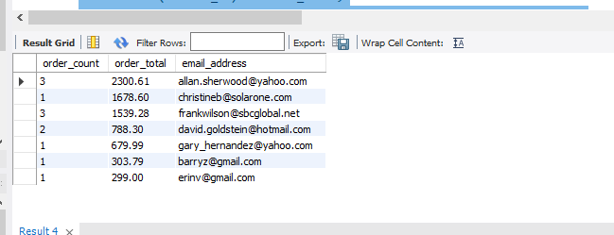

1. Modify the solution to exercise 4 so it only counts and totals line items that have an item_price value that’s greater than 400.

***SELECT COUNT(o.order_id) AS order_count,***

***SUM((item_price - discount_amount) * quantity) AS order_total, email_address***

***FROM customers as c***

***JOIN orders as o ON c.customer_id = o.customer_id***

***JOIN order_items as oi ON o.order_id = oi.order_id***

***WHERE item_price > 400***

***GROUP BY email_address***

***ORDER BY order_total DESC;***

1. 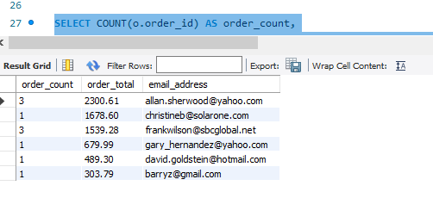
2. Write a SELECT statement that answers this question: What is the total amount ordered for each product? Return these columns:

The product_name column from the Products table

The total amount for each product in the Order_Items table (*Hint: You can calculate the total amount by subtracting the discount amount from the item price and then multiplying it by the quantity*)

Use the WITH ROLLUP operator to include a row that gives the grand total.

*Note: Once you add the WITH ROLLUP operator, you may need to use MySQL Workbench’s Execute SQL Script button instead of its Execute Current Statement button to execute this statement.*

***SELECT product_name, SUM((item_price - discount_amount) * quantity) AS total_product***

***FROM products as p***

***JOIN order_items as oi ON p.product_id = oi.product_id***

***GROUP BY product_name WITH ROLLUP;***

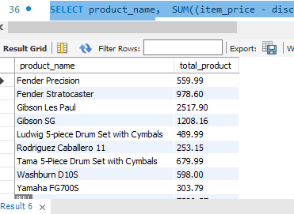

1. Write a SELECT statement that answers this question: Which customers have ordered more than one product? Return these columns:

The email_address column from the Customers table

The count of distinct products from the customer’s orders

Sort the result set in ascending sequence by the email_address column.  
***SELECT email_address, COUNT(DISTINCT oi.product_id) AS count_product***

***FROM customers as c***

***JOIN orders as o ON c.customer_id = o.customer_id***

***JOIN order_items as oi ON o.order_id = oi.order_id***

***GROUP BY email_address***

***HAVING COUNT(DISTINCT oi.product_id) > 1***

***ORDER BY email_address ASC;***

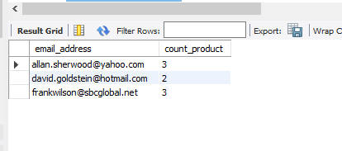

1. Write a SELECT statement that answers this question: What is the total quantity purchased for each product within each category? Return these columns:

The category_name column from the category table

The product_name column from the products table

The total quantity purchased for each product with orders in the Order_Items table

Use the WITH ROLLUP operator to include rows that give a summary for each category name as well as a row that gives the grand total.

Use the IF and GROUPING functions to replace null values in the category_name and product_name columns with literal values if they’re for summary rows.

***SELECT category_name, product_name, COUNT(quantity) as total_count***

***FROM products as p***

***JOIN order_items as oi ON p.product_id = oi.product_id***

***JOIN categories as c ON c.category_id = p.category_id***

***WHERE category_name IS NOT NULL***

***OR product_name IS NOT NULL***

***GROUP BY product_name WITH ROLLUP;***

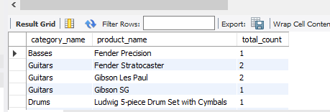

1. Write a SELECT statement that uses an aggregate window function to get the total amount of each order. Return these columns:

The order_id column from the Order_Items table

The total amount for each order item in the Order_Items table (*Hint: You can calculate the total amount by subtracting the discount amount from the item price and then multiplying it by the quantity*)

The total amount for each order

Sort the result set in ascending sequence by the order_id column.

***SELECT order_id, SUM((item_price - discount_amount) * quantity) as totalamount, SUM(Quantity) OVER (ORDER BY order_id ASEC)as total_amount_of_orders***

***FROM order_items***

***GROUP BY order_id;***

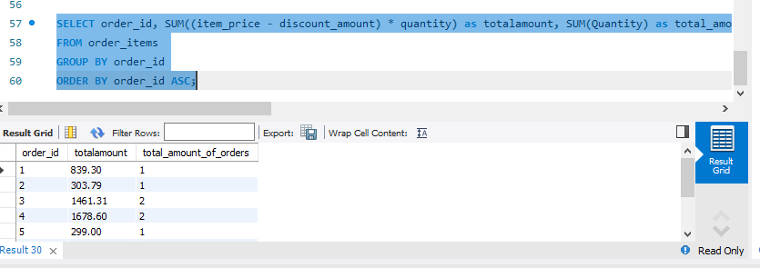

1. Modify the solution to exercise 9 so the column that contains the total amount for each order contains a cumulative total by item amount.

Add another column to the SELECT statement that uses an aggregate window function to get the average item amount for each order.

Modify the SELECT statement so it uses a named window for the two aggregate functions.

***SELECT category_name, product_name, COUNT(quantity) OVER() as total_count***

***FROM products as p***

***JOIN order_items as oi ON p.product_id = oi.product_id***

***JOIN categories as c ON c.category_id = p.category_id***

***WHERE category_name IS NOT NULL***

***OR product_name IS NOT NULL;***

1. Write a SELECT statement that uses aggregate window functions to calculate the order total for each customer and the order total for each customer by date. Return these columns:

The customer_id column from the Orders table

The order_date column from the Orders table

The total amount for each order item in the Order_Items table

The sum of the order totals for each customer

The sum of the order totals for each customer by date *(Hint: You can create a peer group to get these values)*

***SELECT o.customer_id, o.order_date, SUM(oi.item_price), SUM(oi.quantity)***

***OVER (partition by c.customer_id), SUM(oi.quantity) OVER (order by o.order_date)***

***FROM order_items as o JOIN orders as o ON o.order_id = oi.order_id***

***JOIN products as p ON p.customer_id = o.customer_id;***

Part 6

How to code subqueries

Exercises

1. Write a SELECT statement that returns the same result set as this SELECT statement, but don’t use a join. Instead, use a subquery in a WHERE clause that uses the IN keyword.

SELECT DISTINCT category_name

FROM categories c JOIN products p

ON c.category_id = p.category_id

ORDER BY category_name

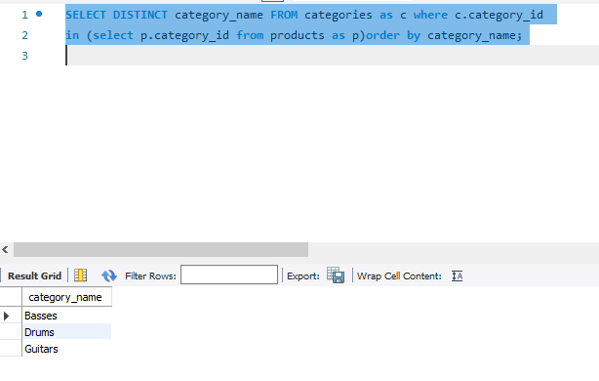

1. Write a SELECT statement that answers this question: Which products have a list price that’s greater than the average list price for all products?

Return the product_name and list_price columns for each product.

Sort the result set by the list_price column in descending sequence.  
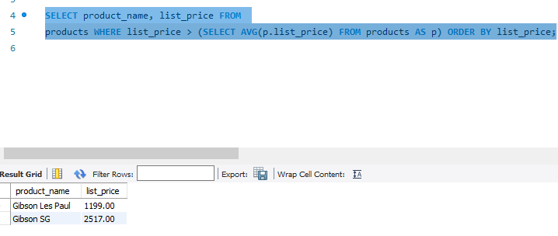

1. Write a SELECT statement that returns the category_name column from the Categories table.

Return one row for each category that has never been assigned to any product in the Products table. To do that, use a subquery introduced with the NOT EXISTS operator.

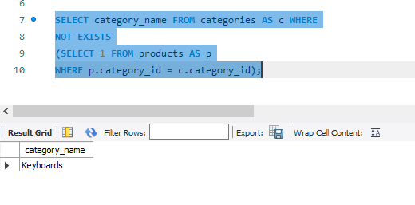

1. Write a SELECT statement that returns three columns: email_address, order_id, and the order total for each customer. To do this, you can group the result set by the email_address and order_id columns. In addition, you must calculate the order total from the columns in the Order_Items table.

Write a second SELECT statement that uses the first SELECT statement in its FROM clause. The main query should return two columns: the customer’s email address and the largest order for that customer. To do this, you can group the result set by the email_address. Sort the result set by the largest order in descending sequence.

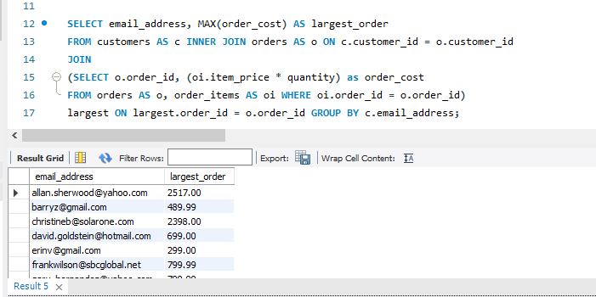

1. Write a SELECT statement that returns the name and discount percent of each product that has a unique discount percent. In other words, don’t include products that have the same discount percent as another product.

Sort the result set by the product_name column.

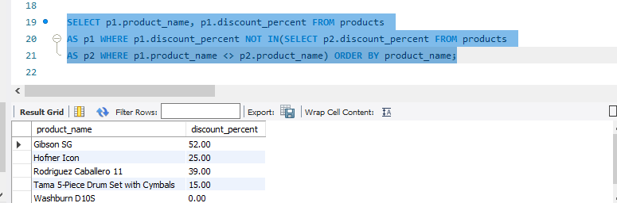

1. Use a correlated subquery to return one row per customer, representing the customer’s oldest order (the one with the earliest date). Each row should include these three columns: email_address, order_id, and order_date.

Sort the result set by the order_date and order_id columns.  
